**CMSC203 Assignment 6 Documentation**

Class: CMSC203 CRN 21525

Program: Assignment 6

Instructor: Khandan Vahabzadeh Monshi

Summary of Description:This project calculated the order from a bevshop

Due Date: 12/16/2024

Integrity Pledge: I pledge that I have completed the programming assignment independently.

I have not copied the code from a student or any source.

Student Name: Amina Elahee

**Part1: UML Class Diagram**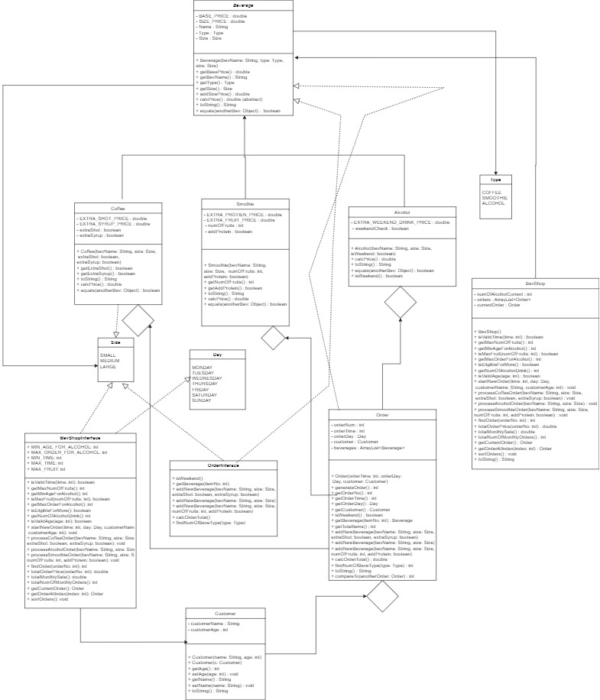

**Part2: Screenshots:**

* + - * 1. Screen snapshots of the BevShopDriverApp (like screenshot in Assignment Description).
        2. Screen snapshots of all Junit Tests
        3. Screen shot of src folder files in your GitHub repository.

**Part3: Lessons Learned** <Provide answers to the questions listed above>**:**

Write about your Learning Experience, highlighting your lessons learned and learning experience from working on this project.

What have you learned?

What did you struggle with?

What would you do differently on your next project?

What parts of this assignment were you successful with, and what parts (if any) were you not successful with?

Provide any additional resources/links/videos you used to while working on this assignment/project.

I have learned about subclasses, iintertfaceclass,enumator classes and how to use them. I mostly struggled with passing the junit test but later I was successful with it. I will try to start early with my upcoming projects.

**Part4: Check List:** <Provide answers to the column Y/N or N/A >**:**

|  |  |  |
| --- | --- | --- |
| **#** |  | **Yor N** |
|  | **Assignment files:** |  |
|  | * FirstInitialLastName_ Assignment6_Complete.zip | **y** |
|  | * FirstInitialLastName_Assignment6.docx/.pdf | **yy** |
|  | * Source java files | **y** |
|  | * JUnit Test Files | **y** |
|  | * FirstInitialLastName_ Assignment6_JavaFiles.zip | **y** |
|  | **Program compiles** | **y** |
|  | **Program runs with desired outputs related to a Test Plan** | **y** |
|  | **Passes Junit Tests** | **y** |
|  | **Documentation file:** | **y** |
|  | * Screen snapshots of the BevShopDriverApp (like screenshot in Assignment Description). | **y** |
|  | * Screen snapshots of all Junit Tests | **y** |
|  | * Screenshots of your GitHub account with submitted Assignment# (if required) | **y** |
|  | * UML Diagram | **yy** |
|  | * Lessons Learned | **y** |
|  | * Checklist is completed and included in the Documentation | y |